A000-EUR-Anatolia-Hittite-Male Figure with metal Mallet-Terra cotta-1250 BCE

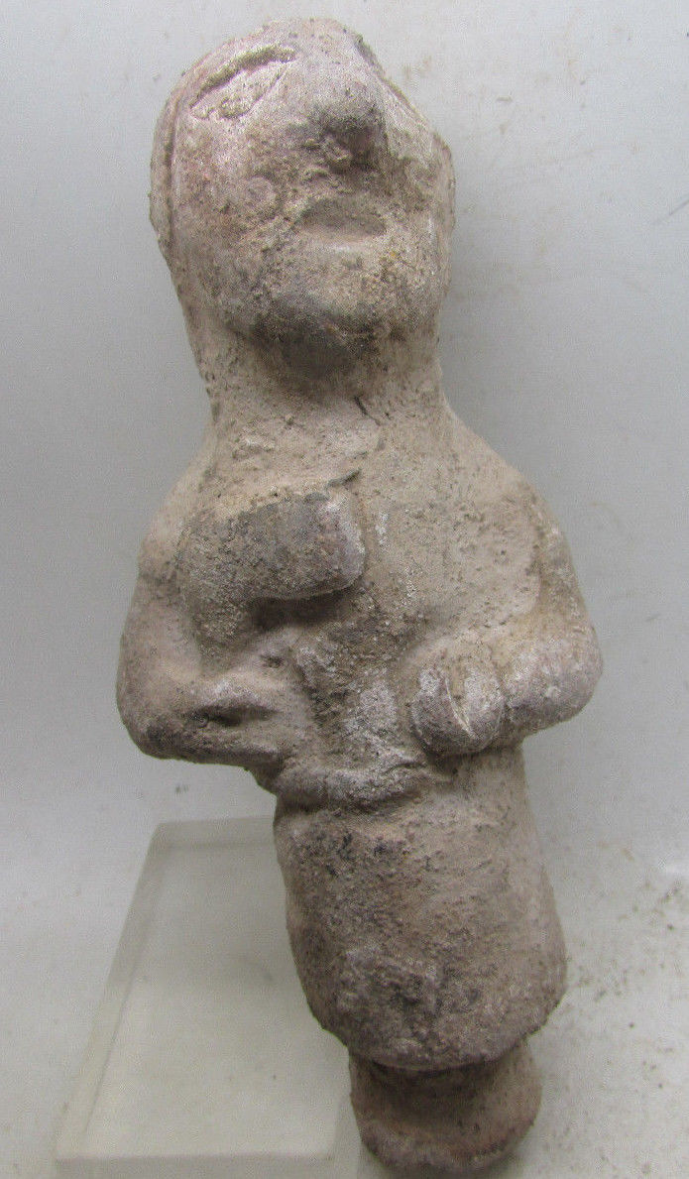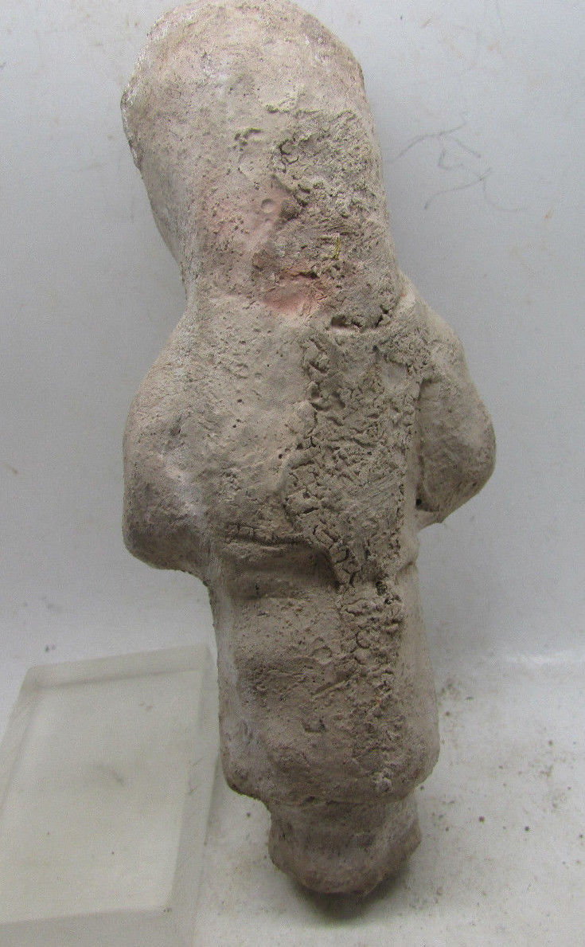

**Case no.:**

**Accession Number:**

**Formal Label:** Anatolia-Hittite-Male Figure with metal Mallet-Terra cotta-1250 BCE

**Display Description:**

Hittite processing of metals was done by smiths (LÚSIMUG) who were associated with kilns and fire and metalworkers, LÚTIBIRA who were associated with metalworking tools. These specialized branches of metallurgical occupations were headed by administrative treasurers (LÚKU3 .DÍM) who were associated with silver smithing, one of the most influential officials of the state administration.(Siegelová 1986: 119-20).. It is possible that this figurine is one of these LÚKU3 .DÍM, since he exhibits a distinctly superior demeanor indicative of his elevated status.

Hittite 13th century economic records indicate one quarter of taxes were paid in raw metals, of which 60 percent was copper, 8 percent was tin and 13 percent was silver but gold and iron were negligible. Hittite 13th century administrative centers and temples, indicate 94 percent of copper, tin and silver assets were processed by silversmith-treasurers (LÚKU3 .DÍM). The Hittite state was committed to metalworking. with finished copper, tin and silver manufactures accounting for 40% of the total in state coffers.

**LC Classification: DS66**

**Date or Time Horizon:** 1250 BCE

**Geographical Area:**

**Map:**

**GPS coordinates:**

**Cultural Affiliation:**

**Medium:** Terra cotta

**Dimensions:** H 11.4 cm

**Weight:**

**Condition: rare**

**Provenance:**

Michael Davies

2 hanover court

Didcot

Oxfordshire

ox11 8nu

United Kingdom

Phone:07948|616659

Email:mike_d456@live.co.uk

**Discussion:**

Hittite iron metallurgy which is much rarer than copper, tin or silver is mentioned in Old Hittite Period Cappadocian sources of the 17th-16th centuries BCE, but it is an unusual metal that was restricted to royal insignia, lances and scepters which were associated with military ritual (Yalçın 1999). Middle Hittite (15th-14th century BCE) cultic use of iron objects included ceremonial axes. *litui* (curved augural staffs) and jewelry. Again the axes and *litui* were associated with military ritual. Then in the 14th and 13th centuries BCE manufacture of iron objects expanded as communities paid taxes in smelted iron. Objects now included anthropomorphic and zoomorphic idols, knives, daggers, swords and spearheads. Interestingly, black or meteoric iron, which known to come from the heavens, was used for the same objects as earthly iron, and there is no evidence of its being sought for any special cultic use (Yalçın 2005).

**References:**

Genz, H. and Mielke, D.P. eds., 2011. *Insights into Hittite history and archaeology*. Leuven: Peeters.

Müller-Karpe, A. 1993: ‘Hethitische Dechsel’. *IstMitt* 43, 227-34

— 1994: *Altanatolisches Metallhandwerk* (Offa-Bücher 75) (Neumünster).

— 1999: ‘Untersuchungen in Kuaklı 1998’. *MDOG* 131, 57-113.

— 1999-2000: ‘Die Akropolis der hethitischen Stadt Ku≥aklı-Sarissa’. *NBA* 16, 91-110.

–– 2000: ‘Zur Metallverarbeitung bei den Hethitern’. In Yalçın, Ü. (ed.), *Anatolian Metal*, vol. 1 (Der Anschnitt Beiheft 13/ Veröffentlichungen aus dem Deutschen Bergbau-Museum Bochum 92) (Bochum), 113-24.

— 2005: ‘Metallbarren bei den Hethitern’. In Yalçın *et al*. 2005, 485-92 Müller-Karpe, H. 1980: *Handbuch der Vorgeschichte*, vol. 4, pt 3 (Munich)

Siegelová, J.1986. *Hethitische Verwaltungspraxis im Lichte der Wirtschafts- und Inventairdokumente,* 3 vols. Prague: Národni Muzeum.

Yalçın, Ü. 1999: ‘Early Iron Metallurgy in Anatolia’. AS, 177-87.

—2005: ‘Zum Eisen der Hethiter’. In Yalçın *et al*. 2005, 493-502.

Yalçın, Ü., Pulak, C. and Slotta, R. (eds.) 2005: *Das Schiff von Uluburun. Welthandel vor 3000 Jahren* (Exhibition catalogue) (Bochum)